Friends and family
Reading: John 15:12, 14-17
Here is my command. Love one another, just as I have loved you.
You are my friends if you do what I command. I do not call you slaves anymore. Slaves do not know their master’s business. Instead, I have called you friends. I have told you everything I learned from my Father. You did not choose me. Instead, I chose you. I appointed you so that you might go and bear fruit that will last. I also appointed you so that the Father will give you what you ask for. He will give you whatever you ask for in my name. Here is my command. Love one another.
Thinking about the reading
In the story of Ruth, there is a lot about families and friends. Naomi loses her family when her husband and sons die, but gains a friend when Ruth promises to stay with her. Boaz is a good friend to Ruth when she is working in the fields. They become family when they get married.
God is a faithful friend to Naomi and Ruth throughout the story. He looks after them and brings them through difficult times. He gives a baby son to Ruth and Boaz. He gives them a place in his family. Many years later Jesus himself will be born as part of the same family.
Jesus is still our faithful friend today. He has chosen each of us to be part of his family. The reading says that he has called us his friends! We are his friends if we do what he tells us. What does he tell us to do? He tells us to love each other as he loves us. We should be faithful friends just as he is a faithful friend to us.
What can we do to be faithful friends? We can look for ways to help others, like welcoming people in church, making a cup of tea for visitors, saying hello to someone on their own. Maybe we could pray for someone who is sad. We can ask Jesus to show us how we can be faithful friends and love one another.

Prayer
Dear Jesus, thank you that you have chosen me to be part of your family. Thank you that you have called me your friend and thank you that you are always a faithful friend to me.
Please help me to be a faithful friend to people around me. Show me what I can do to love others as you love me.
Amen.

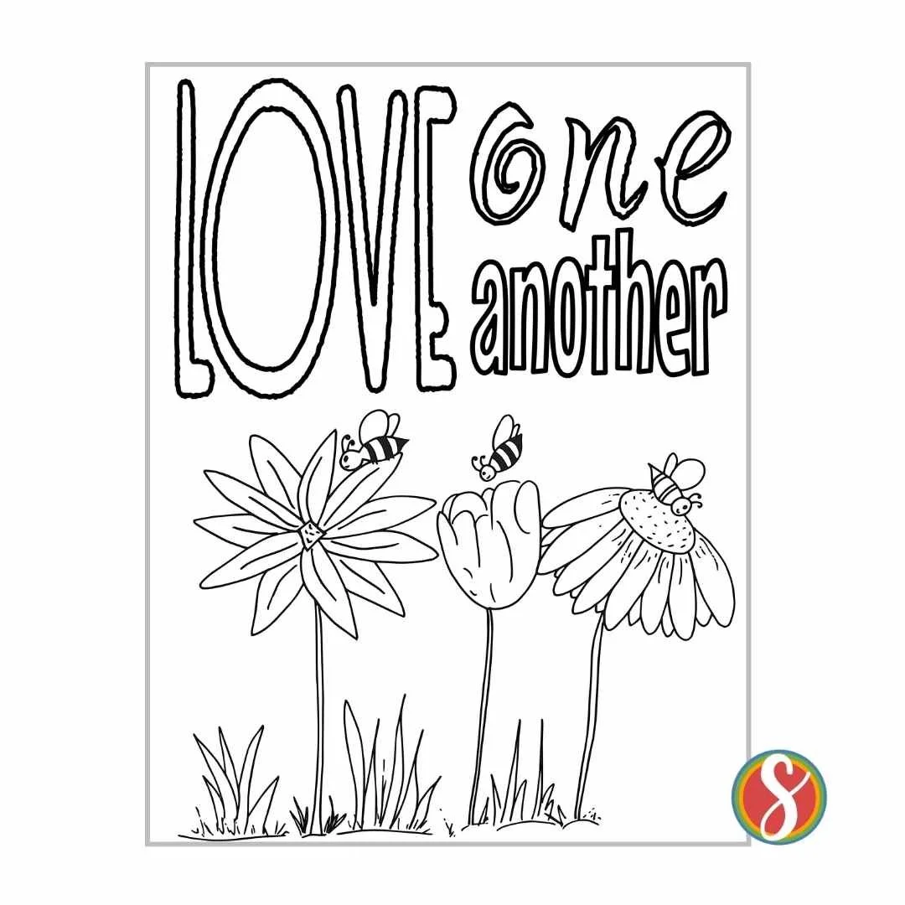

Cambridge Causeway

Summer 2026
Bible Study notes

The Story of Ruth
5. Friends and family
Based on the teaching plan published by Count Everyone In.

The next Causeway meeting will be on September 8th 2026.

